**PROSTHETIC ARM**

**Project Guide**: *Prof Frieda Mohan*

**Submitted by:**

**ASHIQ MEHMOOD.A**

**MIDHUN C. KACHAPPILLY**

**CONTENTS**

1. **AIM**
2. **ABSTRACT**
3. **INTRODUCTION**
4. **TRANSRADIAL PROSTHESIS**
5. **BLOCK DIAGRAM**
6. **LITERATURE REVIEW**
7. **WORK PLAN**
8. **CONCLUSION**

**ABSTRACT**

The proposed model of the Transradial *(below elbow)* prosthetic arm will be designed for a Right Lower arm amputee. The arm will be partially controlled by EMG signals using surface electrodes. The control unit in the prosthetic arm consists of EMG acquisition system, amplifier, filtering system, analog to digital converter which continuously take control signals from amputee hand and work accordingly as per the user’s requirement. Actuator unit includes encoder motors which are present in closed loop system gives a real time signal between the arm and the user. The arm structure is such that it includes five fingers individually controlled by independent actuators. Actuators comprises of a servomotor and its encoder unit. The proposed structure also includes tendon force sensors which can give touch sense through peripheral nerve interfaces. Prosthetic arm is powered by a Lithium-Polymer *(Lipo)* battery.

**INTRODUCTION**

Prosthesis means an artificial device that can replace a missing body part, which may be lost through trauma, disease, or congenital conditions.Prosthetics are intended to restore the normal functions of the missing body part. Different application on human body includes: Arms, Legs, knee, eyes, hip, joints etc.

AIM: To design a medium sized prosthetic arm for right lower arm amputee that gives a Real-Time interface for the user.

*TRANS-RADIAL PROSTHESIS:*

* It is the amputation of the arm below the elbow
* The arm will be partially controlled by EMG signals.

Artificial limb is connected to upper arm muscle using electrodes implanted in them

* Myogram signals are processed and amplified, and used to control motor that actuates motion of prosthetic arm.
* Feedback closed loop provides Real-Time processing signal for coordinated movements.
* Transversal intrafascicular multichannel electrodes (TIMES) is installed in and connected to artificial hand sensors and use this sensation to provide bidirectional control.

**BLOCK DIAGRAM**

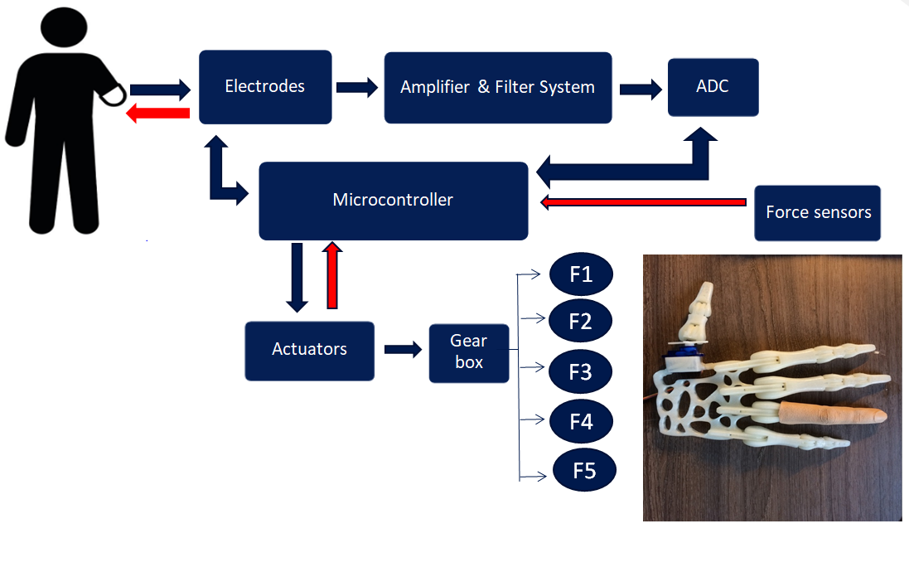

The arm will be partially controlled by EMG signals which originate due to contraction and flexion of upper arm muscles. Myoelectric signals are picked up from the residual limb with the help of surface electrodes. The processing unit in the prosthetic arm consists of EMG acquisition system amplifier, Filtering system, Microcontroller which continuously takes feedback and work accordingly as per the need of the user. Weak signals are amplified and unwanted signals are filtered out leaving behind the necessary function specific signals.

Microcontroller is driven by a feedback closed loop system which gives a real time signal between the arm and the user. The arm structure is such that it includes five fingers individually controlled by individual actuators. Each actuator consists of a servomotor and an encoder unit. This is connected to a gear box along with network of force string system that will drive the finger structures.

The motor will be placed in Proximal inter phalanx with higher gear reduction ratio. The motor proposed to use is small in size with no cogging torque resulting in smooth positioning and speed control. They are encoder motors which gives a correct position of the motor, consecutively help to control the arm accurately using the controllers.

The proposed structure also includes tendon force sensors which can give touch sense through peripheral nerve interfaces. These 6mm diameter load cells are capable of measuring micro-rope/tendon forces up to 100N. It poses a great challenge even with its high benefits.

**LITERATURE REVIEW**

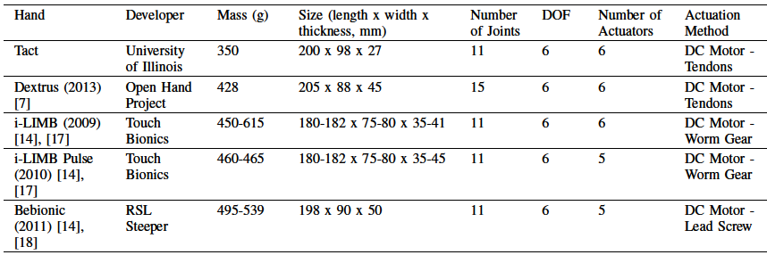

* IEEE transaction on A New Strategy for Multifunction Myoelectric Control of Prosthetics (1993).
* IEEE Conference on Robotics & Automation (2015), TACT-affordable myoelectric prosthetic hand.

**WORK PLAN**

|  |  |  |  |
| --- | --- | --- | --- |
| **WORK SPECIFICATION** | **START DATE** | **END DATE** | **NO:OF DAYS** |
| MODEL DESIGNING | 20/11/18 | 31/12/18 | 40 |
| 3-D PRINTING | 1/1/19 | 20/1/18 | 20 |
| ARDUINO PROGRAMMING | 20/11/18 | 31/1/19 | 70 |
| CIRCUIT DESIGNING | 1/2/19 | 2/3/19 | 30 |
| VERIFYING ALGORITHM | 3/3/19 | 15/3/19 | 13 |
| PROTOTYPE TESTING | 16/3/19 | 25/3/19 | 10 |
| FINAL PRODUCT DESIGN | 26/3/19 | 31/3/19 | 5 |
| TESTING ON USER | 1/4/19 |  |  |

**CONCLUSION**

Thearea of prosthetics is where engineers have to do more things in order to develop a comfortable life for the amputees. In India there is no such development in the area of prosthetic. This is the peak time for us as engineers to do something in order to get a development. As we complete our project we are sure that we can do a great step forward in this area. The completion of our project will make a drastic decrease in the cost of prosthetic, which is affordable by the low average peoples who need a helping hand.